Case Study – Consult for PPP

Client’s Project: Consult for PPP (www.consultforppp.com)
Targeted Location: India

Client’s Introduction & Requirements
The client is the Retired Indian Government Officer and collaboration with more retired middle level as well as junior level officers wanted to launched the “Consult for PPP” to provide complete guidance and consultancy solutions to those companies who’re willing to acquire Government Projects or Tenders.
And, that cannot afford to seek advice from existing corporate consulting companies due to prohibitive cost.
As, the client has already a physical office that only operated with face-to-face consultancy but alongside he not only to promote online their business but also to build a new website related to the business niche that would be the source to contact and provide consultancy solutions.

Challenges that we’re facing
The biggest challenge for us is – the business niche is complete new for us and first we need to understand the whole business and perform activities accordingly.
As client wanted to get his website ready with different consultancy stages available on the website with different kinds of projects.
So our team of developers worked on that to understand the client’s and industry needs and build the entire website.

Strategies that drive results
As the business has completely new website, no social media footprints and didn’t have any digital audience to target. In that case, we opt some of the solutions and collect some valuable information that help us to drive desired results:
- First, we deeply understand the Tendering process, how it works, what kind of documents needed and what are the other sources to grab Tenders information, which helped us to created further strategies and work accordingly.

- Once gathered all the information, our developers ready to code the website as per the client and industry requirements with follow the government regulations.

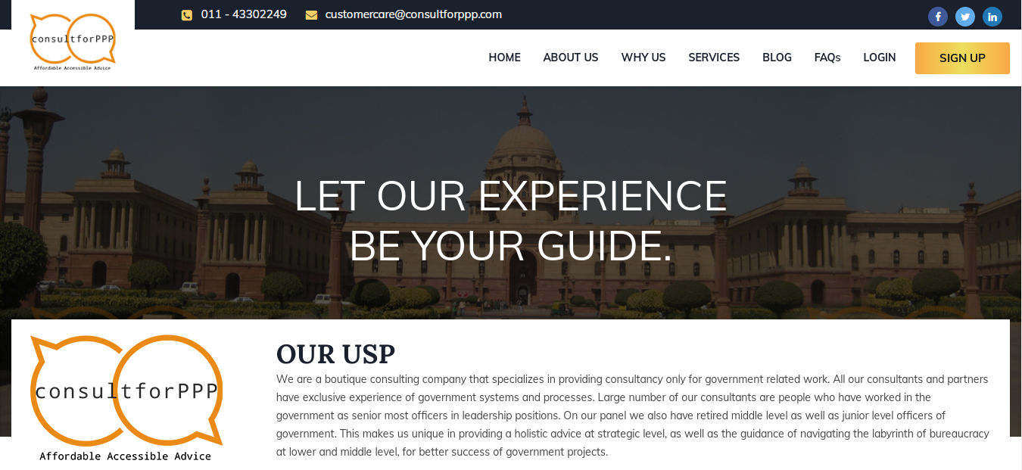

- After successfully coded the website, our Digital Marketing team taken the charge to start promotions online. As we first started analyze the whole website and measure some points that we need to fix in terms of SEO.

- We’ve conducted the Keywords Research for the project, this is another challenge for Digital Marketing team as competition is not so high in the market, they were only limited companies who provide tendering consultancy and limited people who seek advice. Here, needed to found keywords that highly searchable and industry specified.

- Alongside, we’ve created the social media profiles on Facebook, Twitter & LinkedIn – these 3 platforms were the top priority to use as per the business niche that our research found. And, completely optimized as per the social media guidelines.

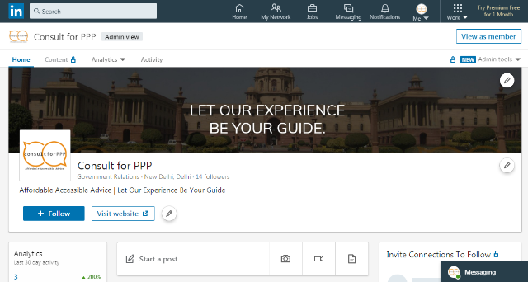
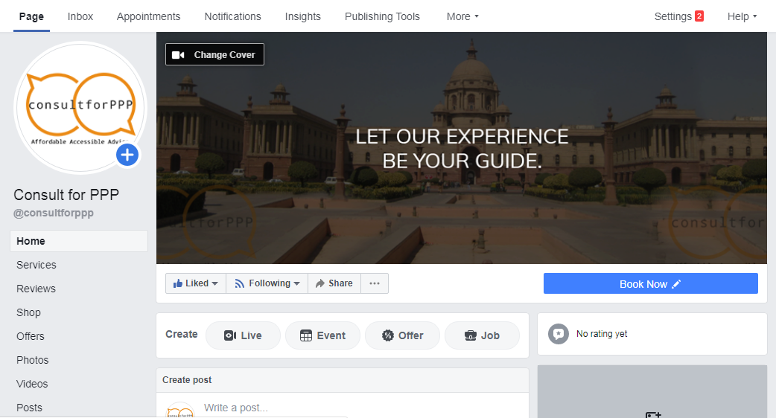

- We’ve also used some tender related as well as online government portals to create business profiles in order to increase business awareness.

- Forums and QnA platforms related to the niche, were the another priority for us to used and give relevant solutions to the users.

- In addition, we’ve performed different activities on social media channels in order to target right audience and generate more leads.

- Some of the social media post examples –

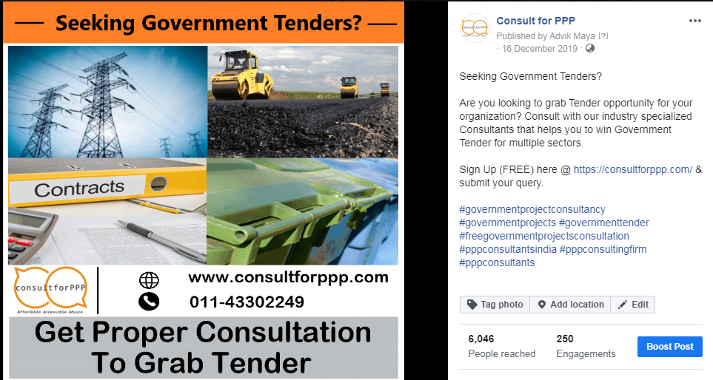

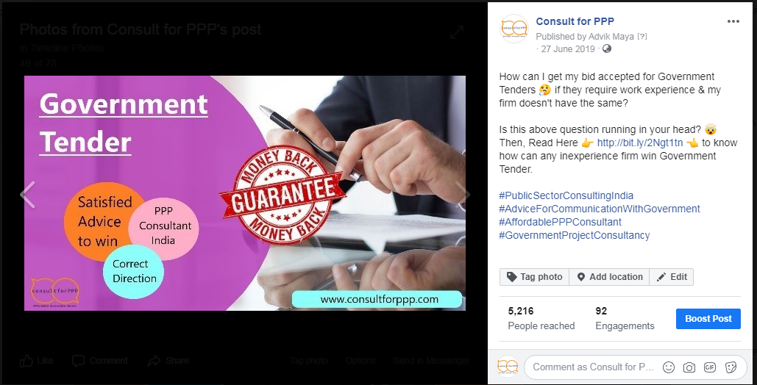

Key Results
Our team helped the client to meet their organizational goals as result it impact on conversion rate and generate quality leads from different sources as mentioned below:
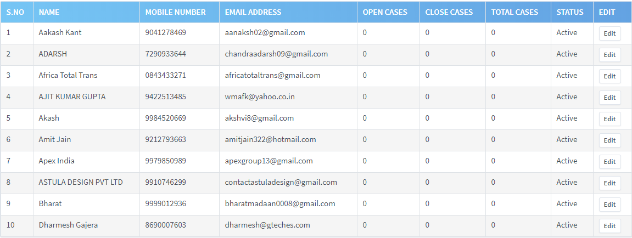
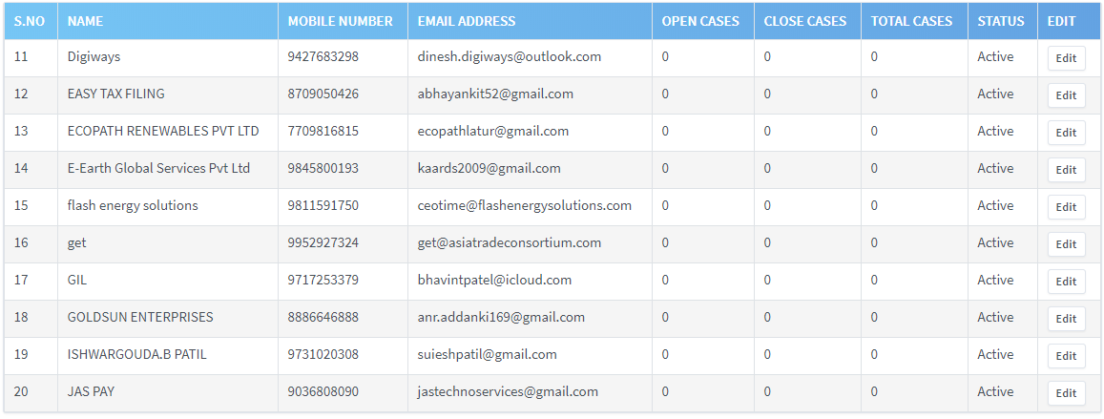
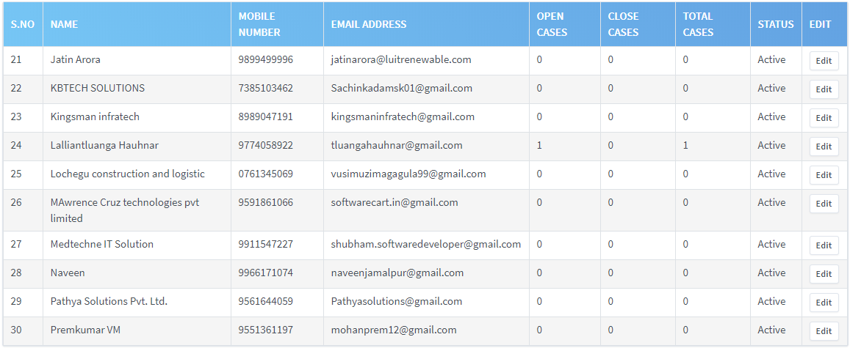
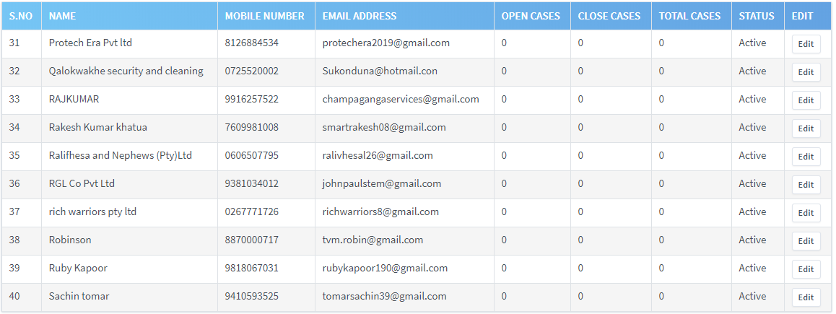
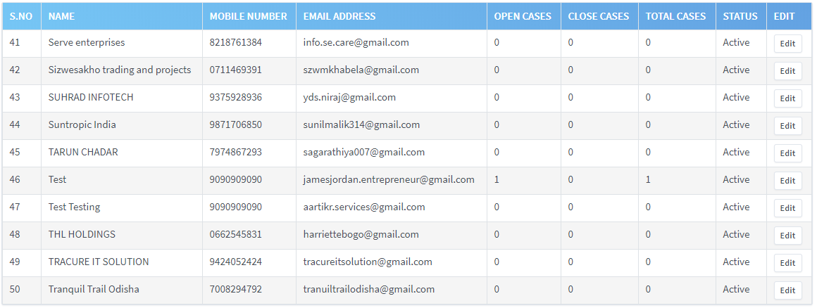
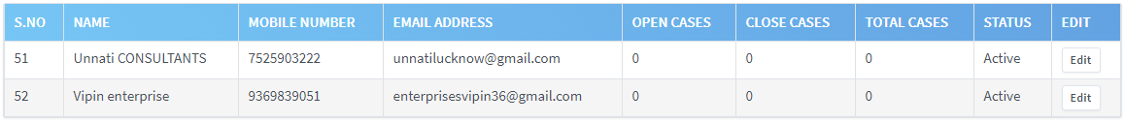

In addition, with the help of implemented different strategies and performed multiple activities we’ve increased search engine rankings on search engines (Google & other) and achieved rank no. 1 on some competitive keywords (mentioned below) –
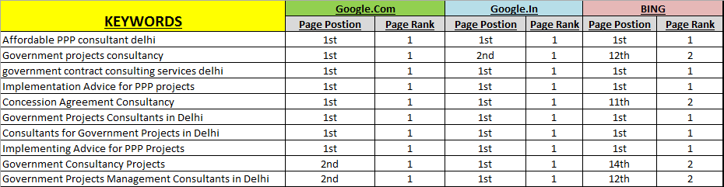
And, the overall traffic increased same like as we planned (mentioned below)
